MODULE: 1 (SDLC)

• **What is software? What is software engineering?**

# Ans=

**Software** is a program or set of programs containing instructions that provide desired functionality. And Engineering is the process of designing and building something that serves a particular purpose and finds a cost-effective solution to problems.

**Software engineering** is the process of designing, developing, testing and maintaining software. It is a systematic and disciplined approach to software development that aims to create high-quality, reliable, and maintainable software. Software engineering includes a verity of techniques, tools, and methodologies, including requirements analysis, design, testing, and maintenance.

• **Explain types of software**

# Ans=

There are main two type of software

1. Application software
2. System software

# 1. Application software

The most common type of software, application software is a computer software package that performs a specific function for a user, or in some cases, for another application

An application can be self-contained, or it can be a group of programs that run the application for the user.

Examples of Modern Applications include office suites, graphics software, databases and database management programs, web browsers, word processors, software development tools, image editors and communication platforms.

Example: Microsoft Office, Paint, Power point etc.

## 2. System software

System software is software that directly operates the computer hardware and provides the basic functionality to the users as well as to the other software to operate smoothly.

Or in other words, system software basically controls a computer’s internal functioning and also controls hardware devices, etc.

The OS is the best example of system software; it manages all the other computer programs.

Example: Notepad, Calculator etc.

* What is SDLC? Explain each phase of SDLC

The Software Development Life Cycle (SDLC) refers to a methodology with clearly defined processes for creating high-quality software.

**The**

**software**

**development**

**life**

**-**

**cycle**

**1**

**Planing**

**2**

**Analysis**

**3**

**Design**

**4**

**Implementation**

**5**

**Testing &**

**integration**

**6**

**Maintananace**

SDLC (Software Development Life Cycle) is a process that produces software with the highest quality and lowest cost in the shortest time possible. SDLC provides a well structured floe of phases that helps an organization to quickly produce high-quality software which is well-tested and ready for production use.

* What is DFD? Create a DFD diagram on Flipkart

DFD Diagram on Flipkart

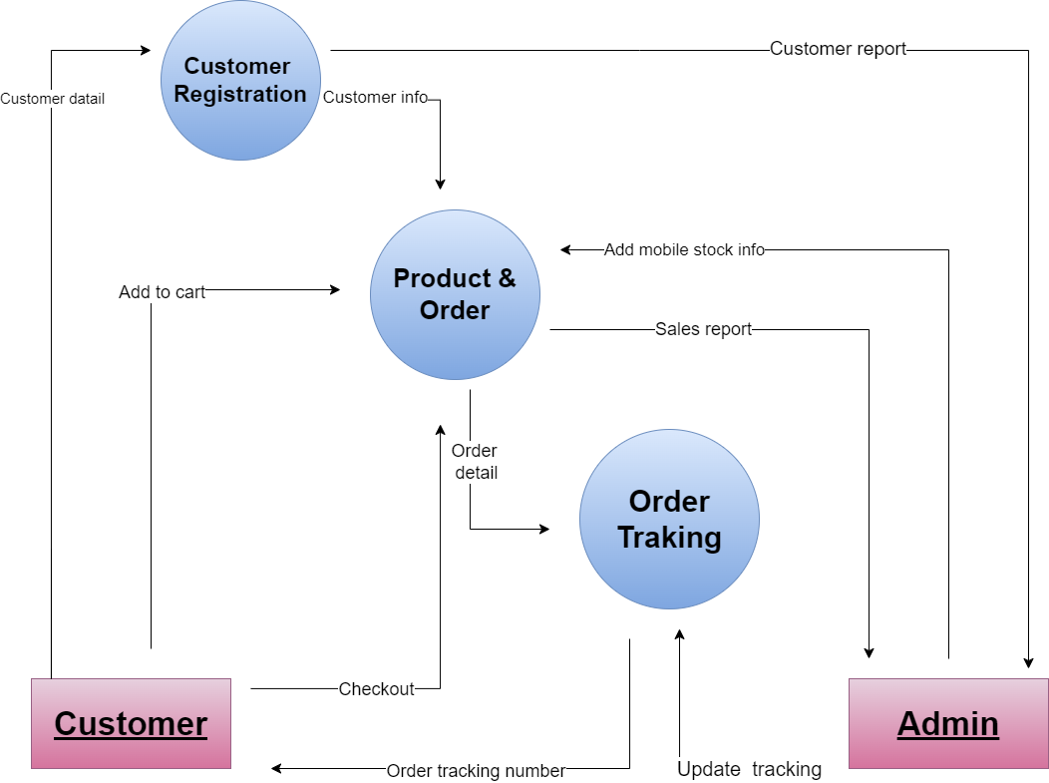

* **What is Flow chart? Create a flowchart to make addition of two numbers**

Flow chart

A flowchart is a type of diagram that represents a workflow or process. A flowchart can also be defined as a diagrammatic representation of an algorithm, a step-by-step approach to solving a task.

**Algorithm**

STEPS=

* Start
* Declare variables num1 and num2
* Read variables num1 and num2
* Add num1 and num2 in sum
* Display sum
* Stop

Code in c language

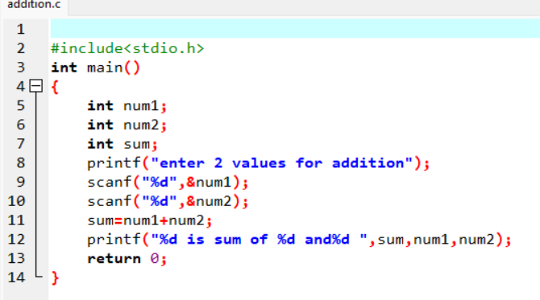

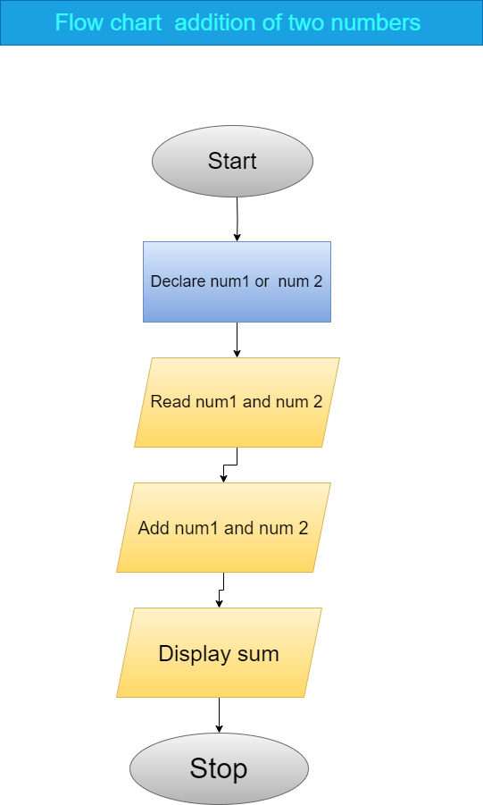

* What is Use case Diagram? Create a use-case on bill payment on paytm.

